Create an alphabet poster with different words in FRENCH for each letter. | Invent a game to memorise the French alphabet. | Draw and write a cartoon in FRENCH where people greet each other, ask each other’s names and ask each other how they are.
Create a word search with the numbers one to 31 and/or items of school equipment. | Make up a mix and match activity using classroom instructions. | Write a poem or song to help you to remember the months of the year in French.
Make a sign for instructions and/or school equipment in French, which will be used for a display in the classroom. | Create a crossword for this topic. The clues may be in English but the answers must be in FRENCH. | Write a poem or song to help you to remember the verb ‘avoir’ and how it is used.
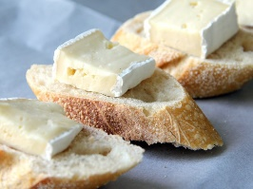
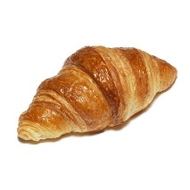
Complete all tasks in order of level of difficulty, start with one start and finish with three star.
Use knowledge organisers to help you.
You may also use the internet to help you if you have access.
Please also learn vocabulary.

