Draw a poster to promote your favourite sport any  writing should be in FRENCH. | Carry out a survey about favourite hobbies. Ask at least 10 people and present your findings in FRENCH. | Ask your PE teacher about sports clubs at your school and design a poster in the FRENCH to promote them. Include the day, time and location.
Create a game which could be used to practise key French verbs. | Write a poem, song or rap to teach the different sports and activities in French. | Imagine you are going to teach regular –er verb endings to the class. Come up with a lesson plan and activities you could use.
Create a wordsearch containing different hobbies, sports and activities in FRENCH. | Create a game to practise regular –er verb endings. | Write a blog post about the hobbies and sports you like and dislike. You should include lots of opinions and reasons.
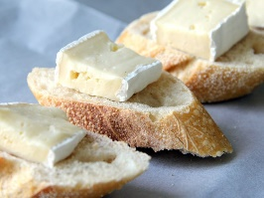
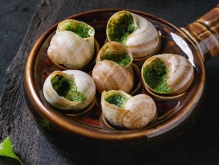
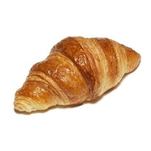
Complete all tasks in order of level of difficulty, start with one start and finish with three star.
Use knowledge organisers to help you.
You may also use the internet to help you if you have access.
Please also learn vocabulary.

