Draw a plan of your dream holiday resort and label what there is there in GERMAN! | Research a holiday location in Germany e.g. Berlin and produce a factsheet about it in GERMAN. You could include the population, size, what there is to see/do there etc. | Create a postcard telling a friend/family member about a recent holiday you have been on. It can be fictional but MUST be written in GERMAN!
Create an English to German dictionary for the topic of ‘holidays’. It must contain AT LEAST 25 entries and be well presented. | Create a vocabulary mat for the topic of ‘holidays’. Using your yellow vocabulary mat to help you. It should contain verbs, adjectives, opinion phrases and connectives. | Write your own poem or song in GERMAN about the topic of ‘holidays’.
Produce a quiz about the topic of holidays. It should include AT LEAST 15 questions about vocabulary and grammar. | Produce a worksheet in GERMAN on a particular aspect of the topic. It should include activities and explanations of any grammar. | Design a webpage for a holiday destination it must be in GERMAN.
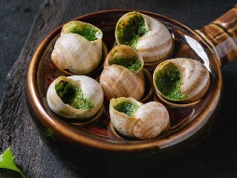
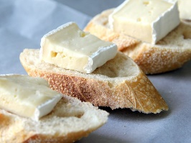
Complete all tasks in order of level of difficulty, start with one start and finish with three star.
Use knowledge organisers to help you.
You may also use the internet to help you if you have access.
Please also learn vocabulary.

