Make a vocab sheet about holidays | Create a brochure advertising a holiday destination in French, use key vocab and verbs to say what is there | Write a full page in your book about where you normally go on holidays & why, a recent holiday & what it was like, an ideal holiday
Research French holiday destinations and create a power point in English about it | Research Easter in France and how it is celebrated. Create a document comparing it to the UK
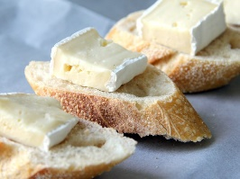
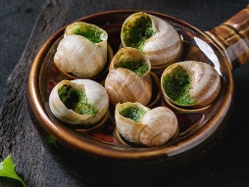
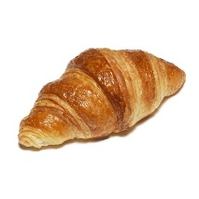
Cultural week: Easter in France
Complete all tasks in order of level of difficulty, start with one start and finish with three star.
Use knowledge organisers to help you.
You may also use the internet to help you if you have access.
Please also learn vocabulary.

