Choose 1 of the events we have studied and create a poster to advertise it. | Choose 1 of the events we have studied and create a display for the classroom to let people know all about it. | Choose 1 of the events we have studied and write an information leaflet to inform tourists about it.
Choose a French musician, singer or group and write a  profile about them. You should include information about them and their music. | Create a quiz for the rest of the class to test their knowledge of this unit. It must contain AT LEAST 15 questions. | Create a webpage for one of the events we have studied. Or if you prefer you can choose another event/festival in France.
Create a calendar for a year in France showing all the different holidays and celebrations that take place. | Write a blog post in FRENCH about the music and films you like/dislike. | Choose a French celebration or festival and compare it to a festival or celebration in England.
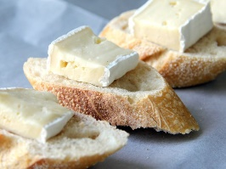
Complete all tasks in order of level of difficulty, start with one start and finish with three star.
Use knowledge organisers to help you.
You may also use the internet to help you if you have access.
Please also learn vocabulary.

