Design a timetable of activities for a summer sports camp in Switzerland. It should include a variety of activities and be written in GERMAN. | Write a blog post about the sports/activities you enjoy in GERMAN. You could write about why you enjoy it, how often you play etc. | Write a letter to your teacher in GERMAN about your plans for the summer holiday using the future/conditional tense – it can be made up!
Create a poster for display to explain how verbs are used when talking about sport. | Design a poster to explain how the perfect tense is formed in German. | Design a webpage for a Swiss summer sports camp it should include information about all the activities, dates, prices etc. and should be in GERMAN.
Ask your PE teacher about sports clubs at school and design a poster in GERMAN to promote them, include the day, time and place. | Draw a poster to promote your favourite sport it must be in GERMAN. | Carry out a survey about favourite pastimes. Ask at least 10 people and present your findings in GERMAN.
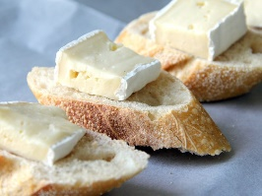
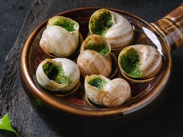
Complete all tasks in order of level of difficulty, start with one start and finish with three star.
Use knowledge organisers to help you.
You may also use the internet to help you if you have access.
Please also learn vocabulary.

