Draw a plan of your dream holiday resort and label what there is there in FRENCH! | Research a holiday location in France e.g. Paris and produce a factsheet about it in FRENCH. You could include the population, size, what there is to see/do there etc. | Create a postcard telling a friend/family member about a recent holiday you have been on. It can be fictional but MUST be written in FRENCH!
Create an English to French dictionary for the topic of ‘holidays’. It must contain AT LEAST 25 entries and be well presented. | Create a vocabulary mat for the topic of ‘holidays’. Using your yellow vocabulary mat to help you. It should contain verbs, adjectives, opinion phrases and connectives. | Write your own poem or song in FRENCH about the topic of ‘holidays’.
Produce a quiz about the topic of holidays. It should include AT LEAST 15 questions about vocabulary and grammar. | Produce a worksheet in FRENCH on a particular aspect of the topic ‘holidays’. It should include activities and explanations of any grammar. | Design a webpage for a holiday destination it must be in FRENCH.
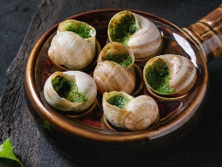
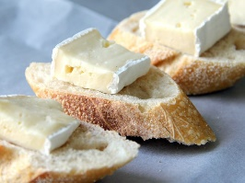
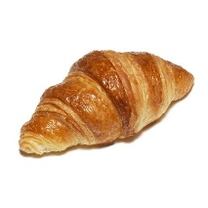
Complete all tasks in order of level of difficulty, start with one start and finish with three star.
Use knowledge organisers to help you.
You may also use the internet to help you if you have access.
Please also learn vocabulary.

