Write 4 sentences about who is in your family | Draw an imaginary family tree & write sentences in French about it, i.e. Ma soeur s’appelle Ariana Grande et… | Write a full page in your book about family & friends – who they are, appearance, personality, your opinions of them
Draw 2 family members & label their hair, eyes, height etc in French | Find a picture of one your favourite people/celebrities or choose a real friend and write a brief physical description of the person | Write a paragraph about what you do at the weekend with family & friends
Create a word search with 30 French words from this topic | Write a description of 2 people in the class in French – be nice! | Print a photo and write a description in French about it
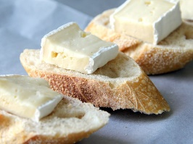
Complete all tasks in order of level of difficulty, start with one start and finish with three star.
Use knowledge organisers to help you.
You may also use the internet to help you if you have access.
Please also learn vocabulary.

