Make a poster to illustrate a healthy and unhealthy diet – pictures and French | Create a brochure giving someone advice about how to lead a healthy lifestyle | Write a full page in your book about healthy and unhealthy lifestyles – what you should/shouldn’t do, opinions
Create a vocab booklet to include all the French/English words and phrases for this topic | Choose a celebrity and give them advice based on their lifestyle
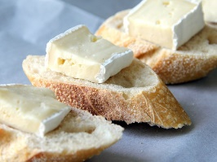
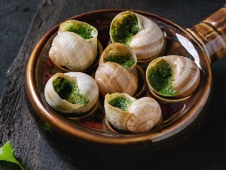
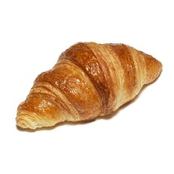
Complete all tasks in order of level of difficulty, start with one start and finish with three star.
Use knowledge organisers to help you.
You may also use the internet to help you if you have access.
Please also learn vocabulary.

